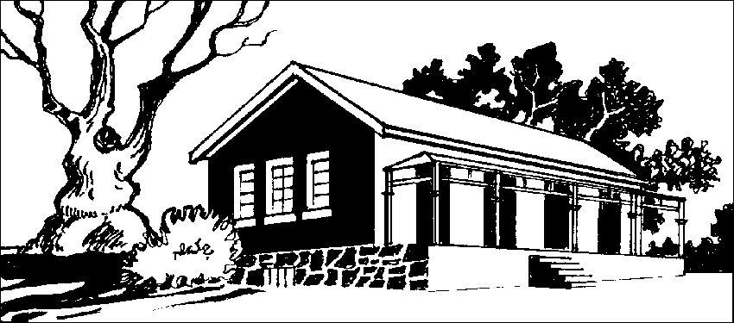
CASTLEMAINE HISTORICAL SOCIETY INC.
FORMER COURT HOUSE, 7 GOLDSMITH CRESCENT
P.O. BOX 655 CASTLEMAINE 3450 (03) 5470 6072
A0009493B email: chsi@castlemainehistoricalsociety.com
URL: www.castlemainehistoricalsociety.com

The Castlemaine Historical Society Inc. is dependent on the members and their membership fees to support this important community entity. Ever expanding services and resources provide people with information they seek in tracing family and local history from early records held in the archives. The Society has gained high regard for the quality of service provided to researchers and the promotion of our rich local heritage.

Thank you for being a Member last year. Your support, encouragement and assistance have contributed to the status achieved. We don’t want to lose you.

I/We

Membership Renewal
* Please help CHSI to keep our records accurate by checking the information below and correcting where required.
_______________________________________________________________
of Postal Address: Residential Address: (if different)

____________________________________________ _________________________________________

____________________________________________ ________________________________________

Home Phone:_________
Business: Mobile:

Emergency Contact Name: Emergency Phone:
(Optional – For members working at the CHSI or other external functions)

Email:

Newsletter by: Email
See Note

Post

wish to renew membership of the Castlemaine Historical Society Inc. I/We agree to be bound by the rules of the Society which are available at the Former Court House or by application.

Signed: (1) ..................................................... (2)..................................................... Date: .........................
Note With the increased cost in postage and its subsequent effect on the Society’s funds, delivery of the monthly newsletter will automatically be via email. Postal mail incurs a $15.00 surcharge. Copies of the Newsletter are available for collection at the Court House.
Annual subscriptions are due and payable on 1 March each year. Membership Classes: (X the box)
(Refer to the back of this form for class description) Membership Fee $............
- Ordinary (Single) | $30 | Newsletter Postage $15 | $............
- Ordinary (Double) | $40 | Fundraiser/Raffle | $............
- Corporate/Group | $55 | Donation (Non-Tax Deductible) | $............
- Associate | No Fee | Donation (Tax Deductible) | $............
 |  | TOTAL | $............
Payment Method: (X the box) Direct Banking Details:

Bank: | Commonwealth Bank - Castlemaine
BSB: | 063 509
Acc. No: | 10028352
CHSI Ref. No: | 778 (or Surname)

Cash (NOT by Mail)
Cheque Money Order Direct Banking

Please complete this form and RETURN with remittance or proof of Direct Banking to the above address.
CHSI Use
Membership Approved on:

